**2018 TASK 15**

**ANSWERS**

**Reactions in Aqueous Solutions and Gases**

MULTIPLE-CHOICE ANSWER SHEET

1. At an increased temperature, the average kinetic energy of the molecules increases.
2. At an increased temperature, the number of molecules with any given energy increases.
3. At an increased temperature, the number of molecules with the energy above any given increase.
4. At an increased temperature, the total area under the curve remains the same.

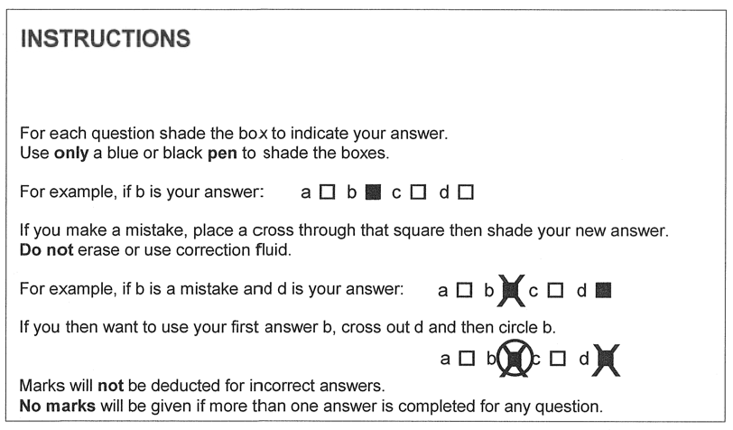

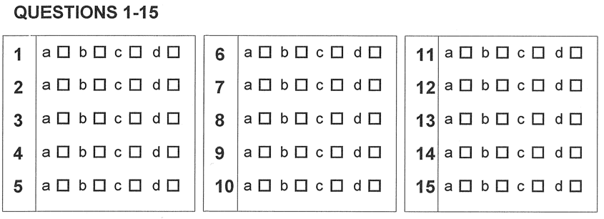

PART B. SHORT ANSWER SECTION (20 marks)

1. When a metal carbonate is added to a beaker containing dilute nitric acid, rapid effervescence occurs. A colourless gas is evolved.

(a) (i) Name the gas. _____**Carbon dioxide**____________ (1)

(ii) How can the gas be identified? (1)

**Bubble the gas through Limewater. ( ½ mark)**

**A white precipitate will be formed, showing that the gas is carbon dioxide.**

**( ½ mark)**

(b) An excess of marble chips is added, with stirring, to dilute sulfuric acid in a beaker. The graph shows the change in electrical conductivity of the solution in the beaker.

Electrical conductivity

P

Q R

Time

(i) Write a balanced Ionic equation for the reaction between marble chips (composed mostly of calcium carbonate) and dilute sulfuric acid. (2)

(states must be shown) **(1 Mark Max for molecular equation)**

**( - ½ for no states)**

**CaCO3(s) + 2 H+ (aq) + SO42- (aq) CaSO4(s) + CO2(g) + H2O(l)**

(ii) Write an observation for the equation above. (1)

**Colourless gas produced** **( ½ mark)**

**White solid dissolves ( ½ mark)**

(iii) What causes the electrical conductivity to drop between P and Q? (1)

**The concentration of mobile ions from H2SO4 decreases as H+ ions are neutralised to form H2O and SO42- ions combine with Ca2+ ions to form the insoluble calcium sulfate. Therefore ions in solution decreasing.**

(iv) Why is there no change in electrical conductivity between Q and R? (1)

**Number of ions in solution has stabilised.**

2. Ammonia gas is liberated when a solid mixture of ammonium sulfate and calcium oxide is heated.

1. Write an Ionic equation for the formation of ammonia gas. (1)

**(NH4)2SO4 (s) + CaO(s) CaSO4(s) + H2O(l) + 2NH3(g)**

1. 4.80 L of ammonia gas was measured under standard conditions (STP), was dissolved in 250 mL of water.
2. Write an Ionic equation for the reaction of ammonia with water. (1)

**NH3(g) + H2O(l)  NH4+(aq) + OH – (aq)**

1. What is the effect of the solution in (b)(i) on litmus paper? Explain your answer. (1)

**Ammonia ionises in water to produce** **OH – ions, which turn red litmus paper blue.**

1. Calculate the number of moles of ammonia gas produced. (1)

**n(NH3(g)) = V/22.71**

**= 4.80/22.71**

**= 0.211 mol**

1. 10.3 g of solid magnesium sulfate was added to the ammonia solution.

Calculate the concentration of the ammonium sulfate produced. (2½)

**n MgSO4(s) = m/M**

**= 10.3**

**120.38**

**= 0.08556 mol (1)**

**MgSO4(s) + 2 NH4OH(aq) ➔ (NH4)2SO4(aq) + Mg(OH)2(s)**

**n (NH4)2SO4(aq) = n MgSO4(s)**

**= 0.08556 mol (½)**

**c (NH4)2SO4(aq) = n / V**

**= 0.08556**

**0.250**

**= 0.342 mol L-1 (1)**

1. Calculate the concentration of the ammonium hydroxide solution required in part (iv). (1½)

**n NH4OH(aq) = 2 x n MgSO4(s) (½)**

**= 2 x 0.08556**

**= 0.1711 mol**

**c NH4OH(aq) = n/V (1)**

**= 0.1711**

**0.250**

**= 0.684 mol L-1**

3. 0.5055g of potassium nitrate, 0.6564g of calcium nitrate, and 0.1829g of cobalt(II) nitrate are dissolved in the same flask of water and the volume made up to 250.0mL.

(State answers to the appropriate number of significant figures)

1. Calculate the number of moles of each substance. (3)

**(1 mark each part)**

**nKNO3 = m/M**

**= 0.5055**

**101.11**

**= 5.000 x 10-3 mol**

**nCo(NO3)2 = 0.1829**

**182.93**

**= 9.998 x 10-4 mol**

**nCa(NO3)2 = 0.6564**

**164.08**

**= 4.000 x 10-3 mol**

1. Calculate the concentration of nitrate ions (in molL-1) (2)

**(1 mark each part)**

**n NO3- = 5.000 x 10-3 + (2 x 9.998 x 10-4 ) + ( 2 x 4.000 x 10-3)**

**= 1.500 x 10-2 mol**

**c NO3- = 1.500 x 10-2**

**0.250**

**= 6.00 x 10-2 mol L-1**

**END OF PART B GO ONTO PART C**